Sample Text for Schools to Inform Parents/Guardians About Nutrition Programs

This template can be customized by schools to inform families about your breakfast/snack program. If possible, we ask that you share this graphic along with the text.
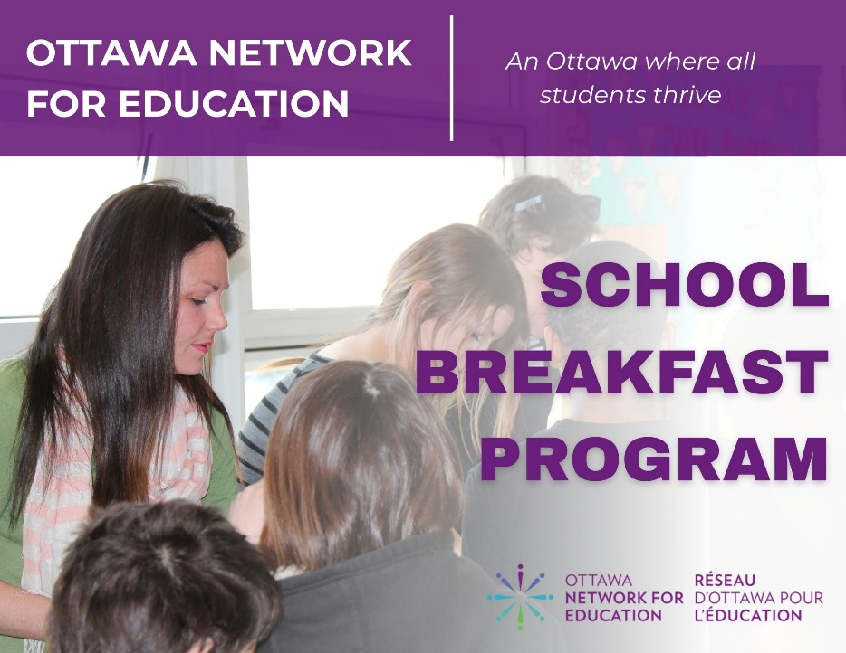
Breakfast Club
Food is fuel for learning. Starting each day with a nutritious breakfast helps students approach school with energy and enthusiasm. Research has shown that eating a healthy breakfast contributes to improved academic performance, school attendance, and classroom behaviour.
Although all students are encouraged to eat breakfast at home, we recognize there may be circumstances that make this difficult. Our Breakfast Club offers a safe and welcoming space for students to start their day. It is available daily at [insert time] in the [insert location].
We serve a variety of healthy foods that meet the Ontario Ministry of Children, Community and Social Services (MCCSS) Student Nutrition Guidelines. Typical items include fresh fruits/vegetables, whole grain foods and protein foods.
Our school’s breakfast program is delivered in partnership with and funded by, the Ottawa Network for Education (ONFE), a registered charity delivering programs to students across Ottawa. The ONFE School Breakfast Program is supported by the Ontario Ministry of Children, Community and Social Services (MCCSS), the National School Food Policy, City of Ottawa, corporate partners and individual donors.
Our school welcomes any parental contributions of volunteer time or money. If you’re interested in supporting, please connect with the office.

Healthy Snack Club
Food is fuel for learning and healthy snacks help keep students energized throughout their school day. Research has shown that eating healthy snacks contributes to improved academic performance, school attendance, and classroom behaviour.
Although all students are encouraged to bring snacks to school, we recognize there may be circumstances that make this difficult. Our Healthy Snack Club is a safe and welcoming space, available daily at [insert time] in the [insert location].
We serve a variety of healthy foods that meet the Ontario Ministry of Children, Community and Social Services (MCCSS) Student Nutrition Guidelines. Typical items include a variety of fresh fruit/vegetables with whole-grain or protein foods.
Our school’s snack program is delivered in partnership with, and funded by, the Ottawa Network for Education (ONFE), a registered charity delivering programs to students across Ottawa. The ONFE School Breakfast Program is supported by the Ontario Ministry of Children, Community and Social Services (MCCSS), the National School Food Policy, City of Ottawa, corporate partners and individual donors.
Our school welcomes any parental contributions of volunteer time or money. If you’re interested in supporting, please connect with the office.

